

**Question/Answer Booklet**

**Name:**

**PHYSICAL EDUCATION STUDIES**

**Yr 11 ATAR**

**Motor Learning and Coaching Test**

**Time allowed for this paper**

Working time for paper: 55 minutes

**Material required/recommended for this paper**

***To be provided by the supervisor***

This Question/Answer Booklet

|  |  |  |  |
| --- | --- | --- | --- |
| **Contents:**  Functional Anatomy | Multiple choice  Short answers  Extended question | 20 marks  43 marks  25 marks  **Total marks** | **/ 88** |

**Multiple Choice (20 marks)**

1. Throwing a dart, can be classified as a:

(a) Discrete, Closed motor skill.

(b) Continuous, Open motor skill.

(c) Serial, Closed motor skill.

(d) Gross, Open motor skill.

1. Augmented feedback in which a coach provides information regarding the outcome or success of the movement to their athlete, is known as:
2. specific feedback.
3. knowledge of results.
4. knowledge of performance.
5. knowledge of feedback.
6. A ten-pin bowler who watches the ball spin and travel path down the lane before then hearing the ball strike into the pins is receiving:
7. extrinsic feedback.
8. augmented feedback.
9. intrinsic feedback.
10. knowledge of performance.

4. During an Inter-School basketball game, a coach shouts out to her players ‘zone defence’, as the ball is turned over from a rebound. This is an example of:

(a) Terminal feedback.

(b) Concurrent feedback.

(c) Constructive feedback.

(d) Intrinsic feedback.

5. In receiving a serve over the net, Phillipa decides to dig and moves accordingly. With reference to the Information Processing Model, this action is known as:

(a) Input.

(b) Output.

(c) Stimulus.

(d) Decision making.

6. Which of the following skills can be classified as the most discrete skill?

(a) 110m hurdles.

(b) Swimming 100m.

(c) Basketball free throw.

(d) Basketball lay-up

7. Knowledge of results is an example of:

(a) Inherent feedback.

(b) Concurrent feedback.

(c) Extrinsic feedback.

(d) Intrinsic feedback.

8. During the second phase of learning, athletes should be encouraged to:

(a) Use their own feedback to detect and correct errors.

(b) Keep the learning environment exactly the same.

(c) Increase their reliance on augmented feedback to perfect the skill.

(d) Develop an understanding of how to perform the skill.

9. Open skills

(a) Very depending on the requirements of the activity or game

(b) Are self-paced

(c) Allow the person to repeat the same executive program or movement

(d) Are performed where the conditions remain unchanged

10. Learning can be broken down into three stages. At the associative stage:

(a) Errors are small and occur less frequently than at the cognitive stage

(b) Most time is spent on tactics and strategies related to the performance

(c) Errors are smaller but occur more frequently than at the autonomous stage

(d) The learner/performer can execute skills without thinking about steps involved

11. Swimming is an example of

(a) Continuous

(b) Discrete

(c) Serial

(d) Fine

12. Cricket uses white balls for day-night matches and red balls for Test matches played

only in daylight. In the information processing model, the use of different coloured balls is

to enhance the;

(a) Identification of stimulus/input phase

(b) Response identification/decision making phase

(c) Response/output phase

(d) Feedback phase

13. Which of the following coaching methods would be most effective when introducing a

beginner to a complex skill?

(a) Brief verbal description of the task

(b) Visual demonstration of the task emphasizing critical elements

(c) Visual demonstration of the task with detailed description of biomechanical principles

(d) Detailed description using key teaching points

14. Knowledge of performance for a golf swing occurs

(a) When this is reviewed as a video replay that includes slowing down key parts

(b) When a golfer compares themselves to a less experienced player

(c) A professional has given you feedback and offered suggestions on body movements

(d) All of the above

15. If a skill is being demonstrated by a coach or an expert performer, it must be:

(a) Suitable to the skill and learning level of performer

(b) Performed at an appropriate speed at which the learner can follow

(c) Demonstrated an adequate number of times so key elements are understood

(d) All of the above

16. When coaching someone at the associative level, it is important to:

(a) Allow for experimentation and discovery where performers come up with the best ways of performing skills

(b) Aim for personal best performances to keep motivation high whilst success might be inconsistent

(c) Keep sessions short to cater for lower concentration and fitness levels

(d) Use sophisticated language and technical terms

17. Which part of the information processing model would the following apply to – playing a smash having seen the ball being hit in the air by your opposition?

(a) Input

(b) Decision making

(c) Output

(d) Feedback

18. In basketball, a player who is fouled while taking a shot is often rewarded a ‘free throw’, whereby the player is allowed to attempt a shot without any defenders involved. The basketball free throw would be classified as which of the following motor skills?

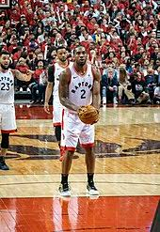

(a) Open and fine

(b) Closed and gross

(c) Closed and fine

(d) Open and gross

19. Visual feedback a basketball player receives as he watches the ball he shot go through the basket.

(a) Knowledge of performance

(b) Knowledge of results

(c) Internal feedback

(d) None of the above

20. During a rest period at swimming training, a coach informs a swimmer that she is not bending her elbow during the freestyle arm stroke recovery. This information given to the student is an example of feedback known as

(a) Extrinsic knowledge of results

(b) Extrinsic knowledge of performance

(c) Intrinsic delayed knowledge of results

(d) Intrinsic delayed knowledge of performance

**Short Answer (43 marks)**

**Question 1 (6 marks)**

Within each training session, coaching a beginner would be quite different to coaching an experienced skilled athlete. Briefly explain how a coach would go about their job in each of these environments.

1. Unskilled beginner

1. Seasoned athlete

**QUESTION 2 (6 marks)**

List 6 things that affect a person’s level of skill.

1. ________________ (ii) ________________ (iii) ________________

(iv) ________________ v) ________________ (vi) ________________

**Question 3 (4 marks)**

The following graph displays data for two (2) athletes practicing their goal kicking in AFL.

(a) Using the data from the graph, identify which athlete was most likely to be in the

cognitive stage of learning. Justify your response. (2 marks)

(b) Using the data from the graph, identify which stage of learning the other athlete

was most likely to be in. Justify your response. (2 marks)

**Question 4 (2 marks)**

Outline the difference between knowledge of results and knowledge of performance.

**Question 5 (3 marks)**

Identify the three purposes of effective feedback.

**Question 6 (10 marks)**

Skills can be classified and defined by the characteristics they possess.

Complete the table below:

|  |  |  |
| --- | --- | --- |
| **Skill Classification** | **Definition** | **Sporting Example** |
| Discrete |  | Swimming dive |
| Gross |  |  |
|  | The skill is performed in a variable / changing environment. | Netball passing in a passage of play |
| Fine |  |  |
|  |  | Triple Jump |
| Continuous |  |  |

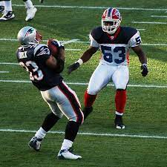**Question 7 (12 marks)**

When getting ready to receive a kick off in NFL, a player is processing a considerable amount of information in preparing

to perform the skill.

1. Draw and label a diagram in the space below which represents the four phases of information processing that could be used to explain the process that the NFL player is experiencing when receiving a kick off. (4 marks)
2. For each phase, describe **one** example that could be applied to the NFL player receiving the ball. (8 marks)

**Extended Answer (25 marks)**

**Question 1 15 marks**

Look at the following diagrams and identify what stage of learning according to Fitts & Posner’s model, you think each picture represents. Identify the characteristics of each stage of learning.

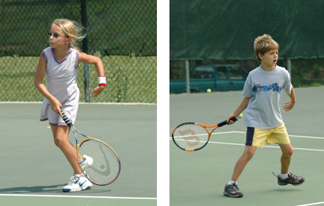

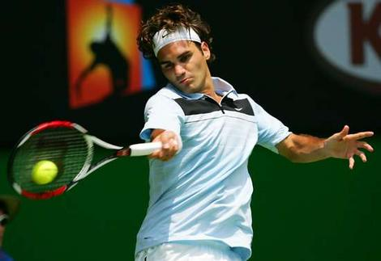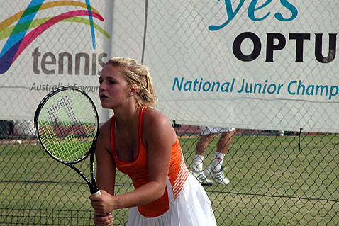

Figure 1. Figure 2. Figure 3.

**Question 2 10 marks**

Anthony is a PT who runs fitness sessions for athlete’s hoping to improve their running ability. He is currently training two athletes, Justine and Ruth. Justine is 20 years old and is new to the sport of long-distance running. She is training to compete in her first half-marathon (21-kilometre event). Ruth is 60 years old and has competed in a number of Ironman races over the past 20 years. After injuring her knee, Ruth, has had a break from training for the past two years. She has entered this year’s 12 kilometre event in the City to Surf.

Although Justine and Ruth are training for the same event, Anthony will need to develop individual training programs for each athlete. Apart from motivation, identify and explain the **four** main factors that Anthony will need to consider when coaching Justine and Ruth.

**End of TEST**

**MARKING KEY**

**Multiple Choice (10 marks)**

|  |  |  |  |  |  |  |  |  |  |  |  |  |  |  |  |  |  |  |  |
| --- | --- | --- | --- | --- | --- | --- | --- | --- | --- | --- | --- | --- | --- | --- | --- | --- | --- | --- | --- |
| 1 | 2 | 3 | 4 | 5 | 6 | 7 | 8 | 9 | 10 | 11 | 12 | 13 | 14 | 15 | 16 | 17 | 18 | 19 | 20 |
| A | B | A | B | B | C | C | A | A | A | A | A | B | A | C | B | C | B | B | B |

**Short Answer (45 marks**

**Question 1 (6 marks)**

Within each training session, coaching a beginner would be quite different to coaching an experienced skilled athlete. Briefly explain how a coach would go about their job in each of these environments.

|  |  |
| --- | --- |
| **Answer Description** |  |
| (a) an unskilled beginner.   * The focus should be on the development of individual rather than team skills. * Feedback should be general to maintain motivation. * Practice sessions should be short to cater for concentration and fitness levels. * Modify rules to reinforce basic skills. * Modify sporting equipment to suit beginners.   (b) a seasoned athlete with a high degree of skill.   * Elite athletes will generally require less direct instruction and feedback from coaches. * They will rely more heavily on internal feedback to make minor modifications * Ensure that mental preparation is adequate since the physical preparation has become routine. * Physical preparation sessions are often of longer duration and higher intensity (due to superior fitness) * Continual practice of game skills is necessary to ensure that team strategies are implemented * A coach at the elite level is more likely to have a range of resources available to assist them in the athlete’s overall preparation (e.g. biomechanist, fitness and conditioning coaches, positional and skill coaches, a sports medicine team, sports psychologists, dieticians) | Max 3 mark  Max 3 mark |

**QUESTION 2 (6 marks)**

List 6 things that affect a person’s level of skill.

* Age
* Gender
* Skill Level
* Training Background
* Fitness Level
* Motivation
* Injuries
* Disabilities

**Question 3 (4 marks)**

The following graph displays data for two (2) athletes practicing their goal kicking in AFL.

(a) Using the data from the graph, identify which athlete was most likely to be in the

cognitive stage of learning. Justify your response

(2 marks)

|  |  |
| --- | --- |
| Description | Marks |
| Athlete B | 1 |
| Greater rate of improvement | 1 |
| Started at a lower level (i.e. lower success rate) | 1 |

(b) Using the data from the graph, identify which stage of learning the other athlete

was most likely to be in. Justify your response

(2 marks)

|  |  |
| --- | --- |
| Description | Marks |
| Athlete A – Associative stage | 1 |
| Reduced rate of improvement | 1 |
| Moderate level of performance | 1 |

**Question 4 (2 marks)**

Outline the difference between knowledge of results and knowledge of performance.

|  |  |
| --- | --- |
| **Answer Description** | **Max 2 marks** |
| **Knowledge of Results**  Feedback (objective) that provides the performer with information regarding the success of their performance in achieving a desired outcome. e.g. time / placing / win / loss.  **Knowledge of Performance**  Feedback (subjective) that a performer receives regarding the quality / execution of their movement or technique. | 1 mark  1 mark |

**Question 5 (3 marks)**

Identify the three purposes of effective feedback.

|  |  |
| --- | --- |
| **Answer Description** | **Max 3 marks** |
| Reinforcement  Improve motivation  Modify future performance | 1 mark  1 mark  1 mark |

**Question 6 (10 marks)**

Skills can be classified and defined by the characteristics they possess.

Complete the table below:

|  |  |  |
| --- | --- | --- |
| **Skill Classification** | **Definition** | **Sporting Example** |
| Discrete | The skill has a definite / observable / identifiable start and finish. Must be restarted upon conclusion.  **1 mark** | Swimming dive |
| Gross | The skill utilises large muscle movements that often require power, speed or strength.  **1 mark** | Weightlifting  (or other specific relevant example).  **1 mark** |
| Open  **1 mark** | The skill is performed in a variable / changing environment. | Netball passing in a passage of play |
| Fine | The skill requires small muscle movements requiring accuracy, precision and coordination.  **1 mark** | Pistol shooting |
| Serial  **1 mark** | The skill has a sub-routines that are linked together to form a more complicated skill or entire motor programme. | Triple Jump |
| Continuous  **1 mark** | The skill does not have an easily identifiable / no definite start or finish. No clear beginning and end. The end of one cycle is the beginning of the next.  **1 mark** | Rowing |

**Question 7 (12 marks)**

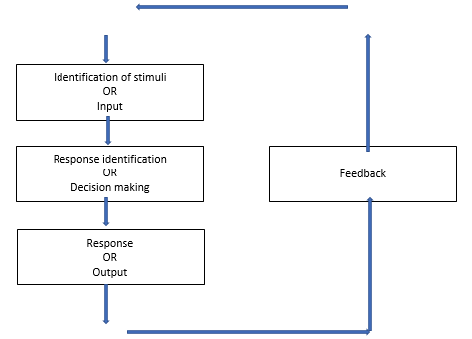

|  |  |
| --- | --- |
| **Description** | **Marks** |
| Labels each phase   * Phase 1 - Identification of stimuli / input * Phase 2 - Response identification / decision making * Phase 3 - Response / output * Phase 4 - feedback | 1  1  1  1 |
| **Total** | **4** |

For each phase, describe **one** example that could be applied to the tennis player receiving serve. (8 marks)

|  |  |
| --- | --- |
| **Description** | **Marks** |
| For each of **four** relevant examples:  Clear description with relevant information included  Simple description with some detail   * Identification of stimuli – player receives information about the environment via their senses, e.g.: flight of the ball coming towards them * Response identification – the brain processes the stimuli and interprets the cues to formulate an appropriate response e.g.: positioning for return of the ball * Response – The brain sends information to the body to respond and perform the action e.g.: catching the ball on the full * Feedback – once the movement is complete the player receives information from their performance e.g.: the success of the returning for touchdown/feedback from coach | 2  1 |
| **Total** | **8** |

**Extended Answer (25 marks)**

**Question 1 15 marks**

|  |
| --- |
| Description |
| Figure 1: COGNITIVE STAGE -1 mark  1 mark each for any 4 of the following;   * Performer learns the nature and demands of the task * Performance level is inconsistent with frequent large errors – trial and error is common * Athletes more concerned with what to do rather than how to do it * Learner begins to develop the basic motor patterns for the task * Movements consciously controlled * Little, if any, cue recognition * All instructions, explanations and feedback must be kept simple * Demonstration of the skill prior to performance and immediate feedback to correct errors is vital * Time spent in this phase is relatively short as the performer will understand task requirements, aims of the game etc. quite quickly.   Figure 2 AUTONOMOUS STAGE -1 mark  1 mark each for any 4 of the following;   * Performer’s movements are fluent, well coordinated and seemingly effortless * Increased speed and accuracy of response to a given situation * Attends to relevant cues only – selective attention is high * Little variability in day to day performance * Able to detect and self – correct errors * Skills are automated * More attention to be given to decision making and the application of tactics and strategies.   Figure 3 ASSOCIATIVE STAGE -1 mark  1 mark each for any 4 of the following;   * Characterised by plenty of practice to develop and consolidate motor programs * Parts of the skill become automatically controlled * Consistency improves * Size and frequency of errors decreases * Feedback contains more specific information * Selective attention improves * The length of time in this phase varies depending on;   + Task complexity   + Level of ability   + Amount of practice   + Amount and quality of feedback * Time in this phase can last from minutes to hours based on above points * External feedback is important but learner begins to understand and use internal feedback themselves * Some learners never move beyond this stage often due to a lack of motivation. |
|  |

**Question 2 10 marks**

|  |  |
| --- | --- |
| Description | Marks |
| Identifies: Age  As Ruth is significantly older than Justine, he will need to consider that she may have:  reduced cardiovascular ability,  reduced flexibility,  more brittle bones  reduced strength and power etc. (any one example is sufficient)  Or  Age can impact factors such as motivation, concentration arousal etc.  (or other relevant explanation) | 1 mark  2 marks |
| Identifies: Skill and/or fitness level  Ruth has greater running experience so her existing knowledge will likely be relatively higher  Or,  Ruth has been previously training for ironman events so her base level of fitness is likely to be relatively higher  (or other relevant explanation) | 1 mark  1 mark |
| Identifies: Injury  Ruth has recently had a knee injury so he should monitor this to avoid further injury (or similar response) | 1 mark  1 mark |
| Identifies: Type of activity  Both athletes are training for a running event however Justine is training for a longer distance event. Her training load will need to increase to a higher level than Ruth. FITT principle.  (or other relevant explanation) | 1 mark  2 marks |